**NGO Darpan**

**Description**: List of Voluntary Organisations and Non Governmental Organisations

**Source**: <https://ngodarpan.gov.in/index.php/search/>

NGO Darpan publishes a list of registered NGOs and VOs that have registered themselves on the Darpan portal. Each NGO/VO that is registered is provided with a unique Id and a Darpan Registration Date. Also published along with these particulars are registration details of the NGO/VO, Sectors, Members, FCRA Details, Achievements, Source of Funds and Contact Details.

**Objective**:

This project intends to collect the list of relevant NGOs and VOs along with important information.

Information to be captured:

1. Obtaining the list:
   1. First Search: On the search page, navigate to NGO Type and select “Private Sector Companies (Sec8/25)”

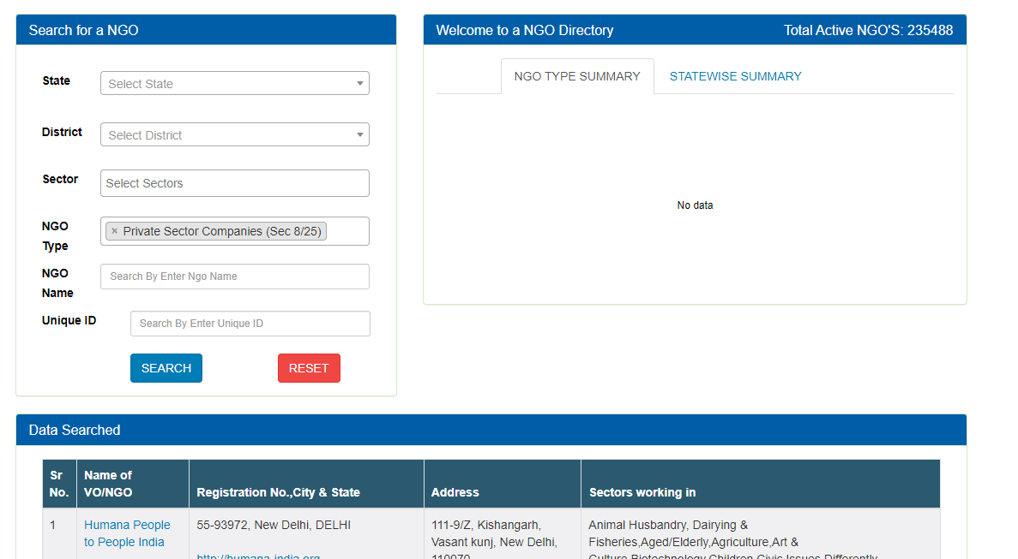

* 1. Second Search: Navigate to “Trust (Non-Government)”, “Other Registered Entities (Non-Government)”, “Academic Institutions (Private)” & “Academic Institutions (Govt)”; and
     1. Enter the value Under “NGO Name”: “Limited” or “ltd”

1. For each search result, we need to extract the relevant details. To do this, the following are the steps:
   1. Click on the “Name of VO/NGO” hyperlink and the “NGO Details” page would appear as a pop-up screen

* 1. From the “NGO Details” we would need to collect the values for the following heads:
     1. Unique Id of VO/NGO
     2. DARPAN Reg. Date
     3. Registered With
     4. Type of NGO
     5. Registration No
     6. Act Name
     7. City of Registration
     8. State of Registration
     9. Date of Registration
     10. Address